Title of your manuscript- a title should be explanatory to explain the entire manuscript writing
[A title has same importance for manuscript acceptance]

Don’t include author name for manuscript submission

Abstract
Explain your work in few lines. Keep the word limit within 250. An abstract is the summarization of the work that completely explains the motivation of the work. Read the complete template before you copy paste your content. The abstract will be in a single paragraph which will not contain any numberings, bulletins, reference, equations, figures tables. The text styles should not be used in abstract writing. While writing an abstract, professionalism should be optimum which could explain the fluency in language and will draw an attention.

Include a suitable descriptive caption.
Need not to be matched with the original caption in the paper.

Keys: use some descriptive words separated by semicolons limited to max. five keys.

1 Introduction

Introduce the content of the paper in brief. Maintain the indentation and the exact template till the last dot of this manuscript. Without this manuscript may be returned without any notice. Introduction should be well groomed in order to visualize the theme of the manuscript. The use of reference starts here [1]. If need to include more than one reference then use [1], [2]. In case if there is use of consecutive references then you should use [5]-[7]. Never give underline to the reference box [4] or never make this bold [5]. Introduction could carry paragraphs but do not include ant point wise paragraphs. Use the simplest way of paragraphing.
Keeping the indentation by using the margin bar is a good practice.

Figure 1 |Caption of the image
Every figure is recommended to be in 500 $×$ 500 aspect ratio. Use any of the MS software to adjust the ration. The standard version of the images are always welcomed with the above resolution.
Style of the text should be Bell MT under size 11 in case of all paragraphs. The headings has to be under 16 size with the same style.

2 Background [Bell MT 16]
Describe the paper background if applicable in this section. The use of any background image is not allowed. Do not use any unnecessary page brake/ column brake.

3 Hyperlink reference creation
The hyperlink use in the reference is must in PTL standard version. Learn below how to create a hyperlink [8].
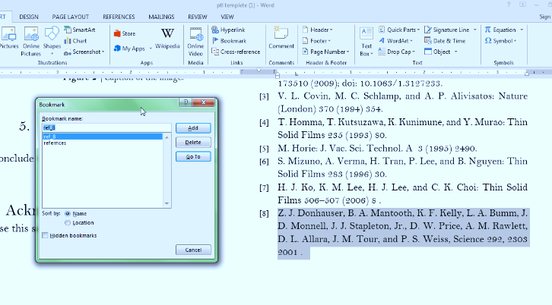
Figure 2 |Select the complete text of the reference
Select the complete text of the reference and click of the insert -> Bookmark.
Give a suitable name for recognition purpose.
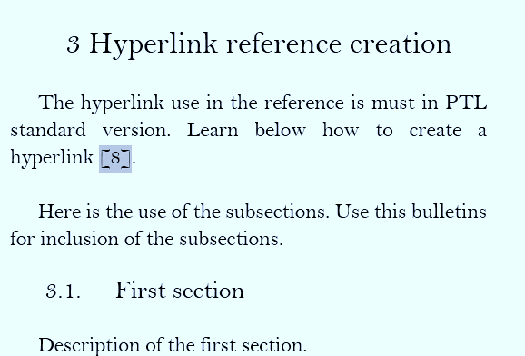
Figure 3 | Now select the target reference you used
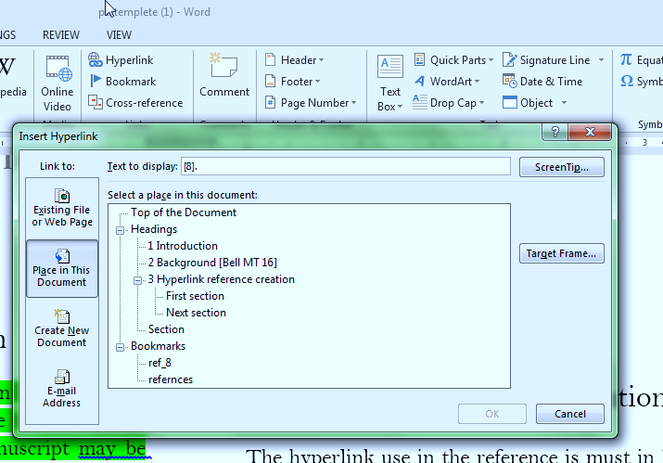
Figure 4 | Now select the hyperlink and use place in this document
Select the hyperlink, use place in this document, select ref 8 as it was already named previously and click on ok. Now the same method should be repeated if your manuscript has repeated reference usage.

Here is the use of the subsections. Use this bulletins for inclusion of the subsections.

First section
Description of the first section.

Next section
Describe this section here. Continue the section as per requirement.

Section
Describe this section here.
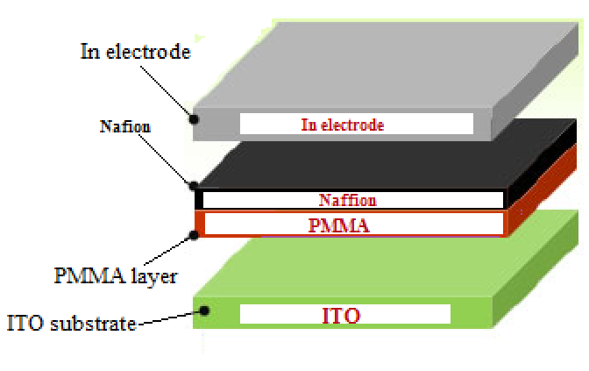

Figure 5 |Caption of the image

- Conclusion

Conclude with the suitable conclusion paragraph. The conclusion section should be elaborative enough to conjugate the proposed theory and the result and discussion sections. There has no word limit but use of the words should be well professional and concise.

Acknowledgement

Use this section if applicable.

References [Use the suitable style as per given]
- Fushan Li, et.al. , "Nonvolatile Memory Effects of ZnO Nanoparticles Embedded in an Amorphous Carbon Layer", Japanese Journal of Applied Physics 49 (2010) 070209.
- Biswanath Mukherjee and Moumita Mukherjee, "Nonvolatile memory device based on Ag nanoparticle: Characteristics improvement" Applied Physics Letters 94, 173510 (2009); doi: 10.1063/1.3127233.
- V. L. Covin, M. C. Schlamp, and A. P. Alivisatos: Nature (London) 370 (1994) 354.
- T. Homma, T. Kutsuzawa, K. Kunimune, and Y. Murao: Thin Solid Films 235 (1993) 80.
- M. Horie: J. Vac. Sci. Technol. A 3 (1995) 2490.
- S. Mizuno, A. Verma, H. Tran, P. Lee, and B. Nguyen: Thin Solid Films 283 (1996) 30.
- H. J. Ko, K. M. Lee, H. J. Lee, and C. K. Choi: Thin Solid Films 506–507 (2006) 8 .
- Z. J. Donhauser, B. A. Mantooth, K. F. Kelly, L. A. Bumm, J. D. Monnell, J. J. Stapleton, Jr., D. W. Price, A. M. Rawlett, D. L. Allara, J. M. Tour, and P. S. Weiss, Science 292, 2303 2001 .

